Check up
- The voltage across a forward-biased silicon diode is approximately
- 0.7V (b) 0.3V (c) 0V (d) dependent on the bias voltage
- In Figure 1, identify the forward-biased diode(s).
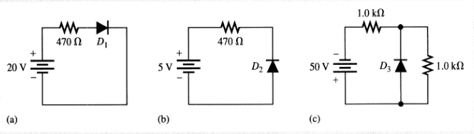
Figure 1
- When the positive lead of an analog ohmmeter is connected to the cathode of a diode and the negative lead is connected to the anode, the meter reads
- A very low resistance (b) an extremely high resistance or open
(c) a high resistance initially, decreasing to about 100Ω
(d) a gradually increasing resistance
4. The output frequency of a full-wave rectifier with a 60Hz sinusoidal input is
(a) 30Hz (b) 60Hz (c) 120Hz (d) 0Hz
5. if a single diode in a center-tapped full wave rectifier opens, the output is
(a) 0V (b) half-wave rectified (c) increased in amplitude (d) unaffected
6. During the positive half-cycle of the input voltage in a bridge rectifier,
(a) one diode is forward biased (b) all diodes are forward biased
(c) all diodes are reverse biased (d) two diodes are forward biased
7. The process of changing a half-wave or a full-wave rectified voltage to a constant DC voltage is called
(a) filtering (b) AC to DC conversion (c) damping (d) ripple suppression
8. Zener diodes are widely used as
(a) current limiters (b) power distributors (c) voltage regulators (d) variable resistors

Problems
- Sketch the waveforms for the load current and voltage for Figure 1. Show the peak value.
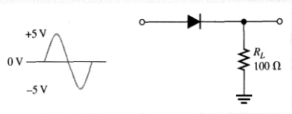
Figure 1
- Determine the peak voltage and peak power delivered to R_{L} in Figure 2.
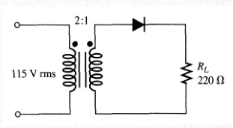
Figure 2
- Figure 3 shows a zener diode regulator designed to hold 5.0V at the output. Assume the zener resistance is zero and the zener current ranges from 2mA minimum ( I_{ZK} ) to 30mA maximum ( I_{ZM} ). What are the minimum and maximum inout source voltages for these current?
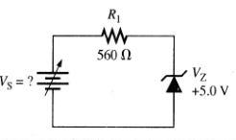
Figure 3
- From the meter readings in Figure 4, determine the most likely problem. State how you could quickly isolate the exact location of the problem.
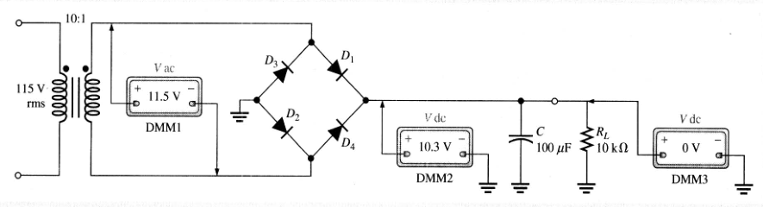
Figure 4

